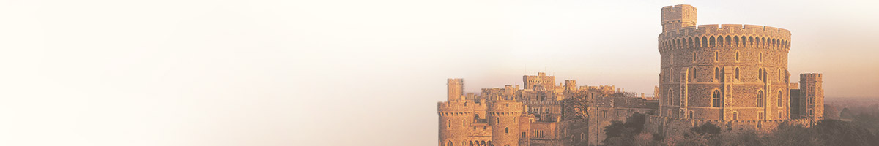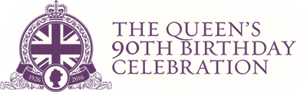
FREE! FREE! FREE!
Groups and residents of Alburgh village have come together to hold a celebration for Queen Elizabeth II’s 90th Birthday. The event will take place at Alburgh village hall starting at 2pm on Saturday 11th June 2016.
The proposed timeline for events are as follows.

2pm. Onwards
- Displays of Photos and memorabilia depicting life over the last 90 years.
- Teas & Cakes
- Children’s craft table.
- Face painting.
- Raffle tickets available.(In aid of East Anglia Air Ambulance)

3.30pm
- Children’s Fancy Dress Competition to be judged by Dr Murray Gray.
- Age groups; 4–6, 7-10, 11–14 with a prize for the best King and Queen in each group.

4.00pm – 7pm
- Mark Steele Guitar Vocalist with music through the decades.
- Hot dogs. (1 per person )
- Raffle will be drawn at approx 5pm.

This event is open to and for everybody, who wishes to attend so if you would like to help or contribute in any way please contact Keith Donno. (01986 788 732). As much as possible will be free subject to availability. So please come along and have a fun time with friends and family to mark this special occasion.
All Donations and monies raised will be donated to East Anglia Air Ambulance.

Please note: Bar, Raffle, Face painting and any additional hot dogs are not free!
All events and times are approximate and may be subject to change.

